Mat 110 Quiz 4 Review Name:________________________
- Sketch the graph of $f\left(x\right)=\frac{1}{20}{(x-2)}^{3}{(x+1)}^{3}{(3x+1)}^{2}$ and then answer the questions below.
  - Number of local extrema ______________, $x$-intercepts _________________ $y$-intercepts ___________
  - Leading Coefficient of $f(x)$ is __________ and degree of $f\left(x\right)=$____________
  - End Behavior of $f\left(x\right)$ is like $y=$________ function.
  - Intervals where$\frac{1}{20}{(x-2)}^{3}{(x+1)}^{3}{(3x+1)}^{2}≥0$ are ________________________
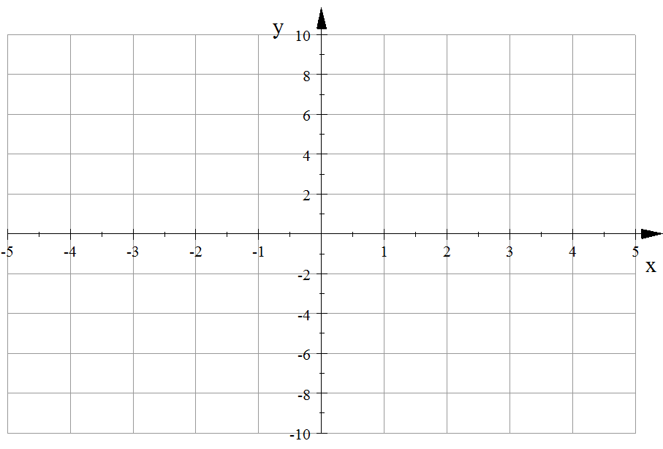

- Given the graph of the function $y=f(x)$ determine a rough sketch of the function $y=\frac{1}{f(x)}$. Show all your asymptotes clearly (use colored pens). Explain clearly your logic.
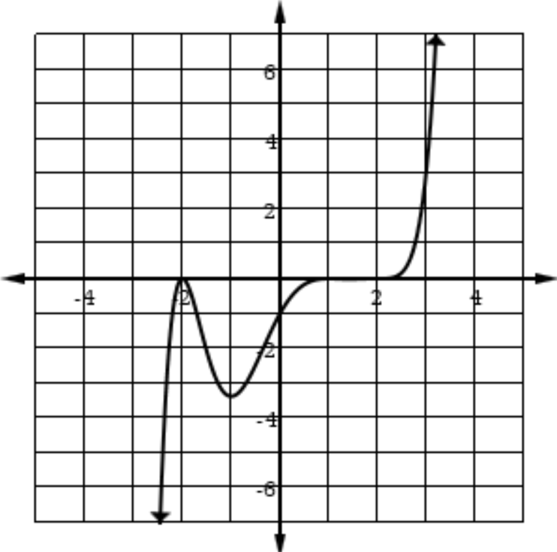

- Sketch the graph of the following the functions below and fill in the blanks.
- $f\left(x\right)=\frac{3x-1}{x-2}$ ,  Asymptotes are __________  $x$-intercepts ______ $y$-intercept _________  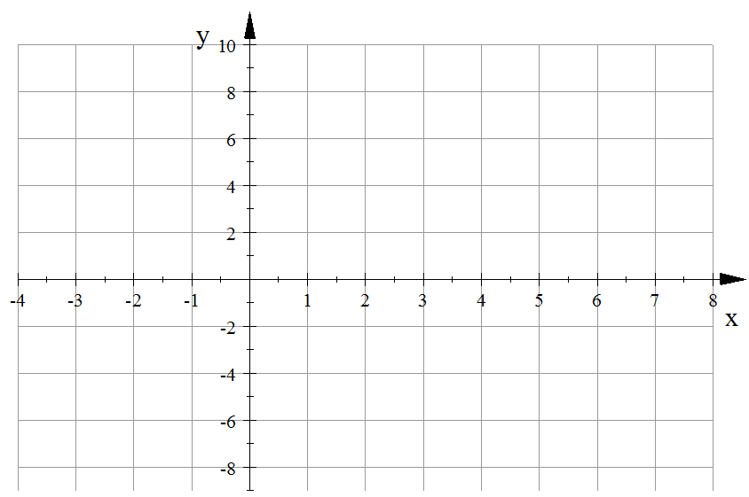 | - $f\left(x\right)=\frac{{(x-2)}^{2}}{x-1}=x-3+\frac{1}{x-1}$  Asymptotes are __________  $x$-intercepts ______ $y$-intercept _________  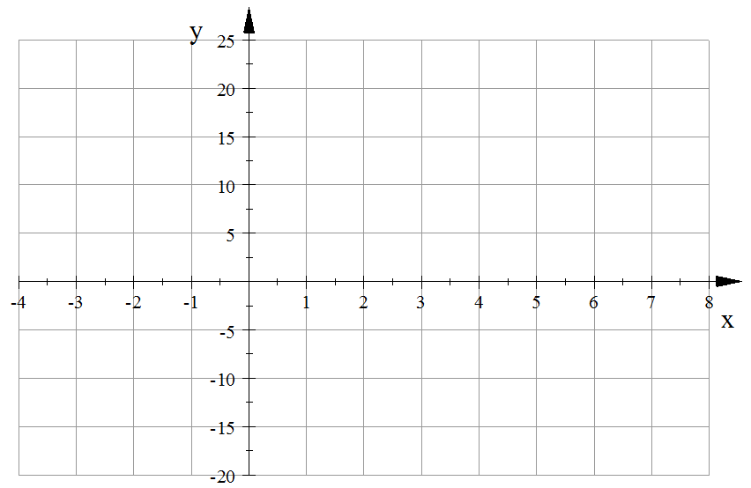

- $g\left(x\right)=\frac{{(x+1)}^{2}{(x-2)}^{2}}{{(x-1)}^{2}}=x^{2}-4-\frac{4x-8}{({x+1)}^{2}}$

Asymptotes are :___________________ $x$-intercpets ________ $y$-intercept _____

Points of intersection with the asymptotes are ___________

Intervals where $\frac{{(x+1)}^{2}{(x-2)}^{2}}{{(x-1)}^{2}}>0$ are __________________
